KARNATAK LAW SOCIETY’S

GOGTE INSTITUTE OF TECHNOLOGY

UDYAMBAG, BELAGAVI-590008

(An Autonomous Institution under Visvesvaraya Technological University, Belagavi)

**(APPROVED BY AICTE, NEW DELHI)**



*Course Activity Report*

**Track my Friend App**

*Submitted in the partial fulfillment for the academic requirement**of*

***7th Semester B.E.***

***in***

***Mobile Application Development Laboratory***

*Submitted by*

**Venkatesh G Dhongadi**

**2GI19CS175**

**GUIDE**

### Prof. Prasad Pujar

**2022 – 2023**

GOGTE INSTITUTE OF TECHNOLOGY

UDYAMBAG, BELAGAVI-590008

(An Autonomous Institution under Visvesvaraya Technological University, Belagavi)

**(APPROVED BY AICTE, NEW DELHI)**

**Department of Computer Science and Engineering**

**CERTIFICATE**

This is to certify that the students **Venkatesh G Dhongadi** of **7th** semester bearing USN’s **2GI19CS175** have satisfactorily completed the course activity (Project) in **Mobile Application Development** course (Course code: **18CSL78**). It can be considered as a bonafide work carried out in partial fulfillment for the academic requirement of **7th** Semester B.E prescribed by KLS Gogte Institute of Technology, Belagavi during the academic year 2022- 2023.

The report has been approved as it satisfies the academic requirements in respect of Assignment (Course project) prescribed for the said Degree.

Signature of the Faculty Member        Signature of the HOD

Date:

**Marks allocation**

|  |  |  |  |  |  |  |
| --- | --- | --- | --- | --- | --- | --- |
|  | Batch No.: | | | | | |
| 1. | Project Title:  Track my Friend app | Marks Range |  | | | |
|  |  |  |  |
| 2. | Abstract (PO2) | 0-2 |  |  |  |  |
| 3. | Application of the topic to the course (PO2) | 0-3 |  |  |  |  |
| 4. | Literature survey and its findings (PO2) | 0-4 |  |  |  |  |
| 5. | Methodology, Results and Conclusion (PO1, PO3, PO4) | 0-6 |  |  |  |  |
| 6. | Report and Oral presentation skill (PO9, PO10) | 0-5 |  |  |  |  |
|  | Total | 20 |  |  |  |  |

**\* 20 marks is converted to 10 marks for CGPA calculation**

1. **Engineering Knowledge:** Apply the knowledge of mathematics, science, engineering fundamentals and an engineering specialization to the solution of complex engineering problems.
2. **Problem Analysis:** Identify, formulate, review research literature, and analyze complex engineering problems reaching substantiated conclusions using first principles of mathematics, natural sciences and Engineering sciences. **3.Design/Development of solutions:** Design solutions for complex engineering problems and design system components or processes that meet the specified needs with appropriate consideration for the public health and safety, and the cultural, societal, and environmental considerations.
3. **Conduct investigations of complex problems:** Use research-based knowledge and research methods including design of experiments, analysis and interpretation of data, and synthesis of the information to provide valid conclusions.
4. **Modern tool usage:** Create, select, and apply appropriate techniques, resources, and modern engineering and IT tools including prediction and modeling to complex engineering activities with an understanding of the limitations. **6.The engineer and society:** Apply reasoning informed by the contextual knowledge to assess societal, health, safety, legal and cultural issues and the consequent responsibilities relevant to the professional engineering practice.
5. **Environment and sustainability:** Understand the impact of the professional engineering solutions in societal and environmental contexts, and demonstrate the knowledge of, and need

for sustainable development.

1. **Ethics:** Apply ethical principles and commit to professional ethics and responsibilities and norms of the engineering practice.
2. **Individual and team work:** Function effectively as an individual and as a member or leader in diverse teams, and in multidisciplinary settings.
3. **Communication:** Communicate effectively on complex engineering activities with the engineering community and with society at large, such as, being able to comprehend and write effective reports
4. **Project management and finance:** Demonstrate knowledge and understanding of the engineering management principles and apply these to one's own work, as a member and leader in a team, to manage projects and in multidisciplinary environments.
5. **Life-long learning:** Recognize the need for and have the preparation and ability to engage in independent and lifelong learning in the broadest context of technological channel

**TRACK MY FRIEND APP**

**PROBLEM STATEMENT**

There might be a time when someone wants to get the location of their friends. The result could be losing a chance to hang out and catch up with colleague or missing out on meeting someone dear that they will probably never be able to see again. Either way, it is unfortunate not being able to have a mobile service that can prevent such circumstances when most mobile phones are equipped with a Geographical Positioning System (GPS) and tools to define and manage users' connections.

Thus, develop an app to show your friends location.

**INTRODUCTION**

Mobile phones have become a major part of our daily lives. The importance of them is since they are an easy way of communication, Internet access and social media. They also save money, ensure safety, help in business and many more.

Mobile phones can support a wide range of applications, giving them many of the same functions available on a laptop but without the extra bulk.

Anyone who has a smart phone or another mobile device probably uses apps to play games, get directions, access news, books, weather, and so on. Mobile apps are easy to download, are often free and are convenient such that sometimes users might download them without thinking about some key considerations: how they are paid for, what information they may gather from the device, or who gets that information.

There is a need to continue to develop new apps that serve the growing demands of mobile users. The market of mobile apps makes use of new mobile and hardware technologies, and therefor expands with the expansion of these technologies.

During the past few decades, advancements in technology have been exceptionally fast, especially in computer and mobile technologies. This fast improvement resulted in a need to develop applications and services that enhance human lives.

Global Positioning System (GPS) is the technique that is used to determine the position of objects on the Earth surface. This technique has become widely used in many desktop and mobile applications.

In this project, we developed FriendTracker, which is a mobile application that tracks/locates them from their recent location using their GPS. The user can check their friends location by tapping in their friends list.

**FUNCTIONAL BLOCK DIAGRAM**

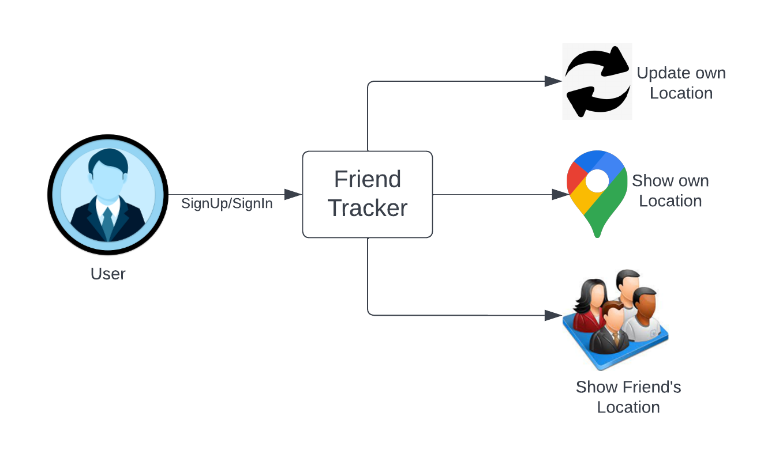

**WORKING MODEL**

**Login Page:**

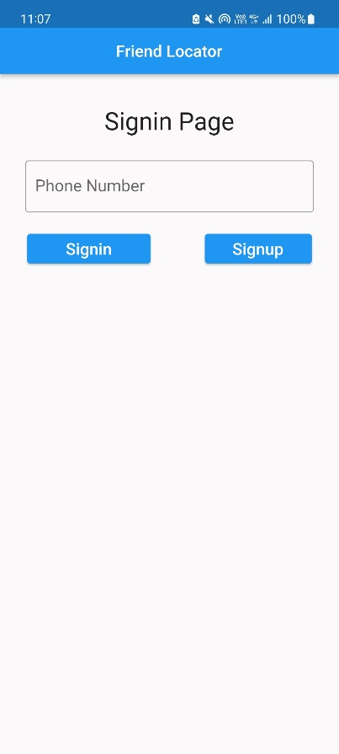

**Contents:**

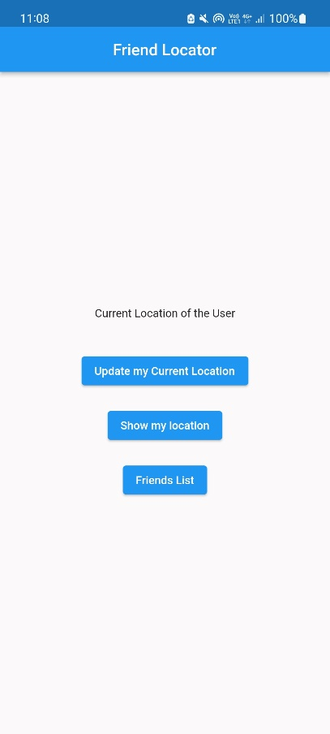

**Location Update:**

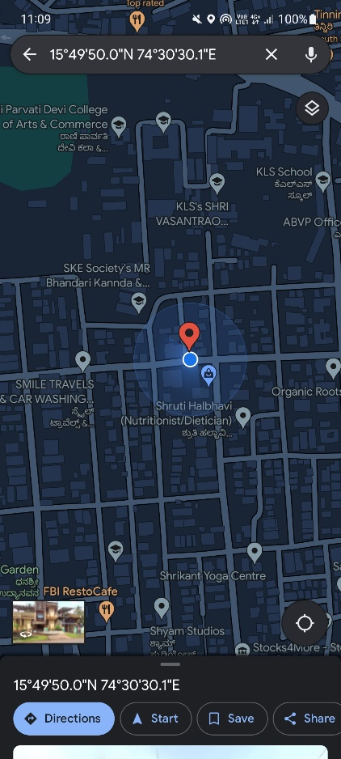

**Friend’s Location:**

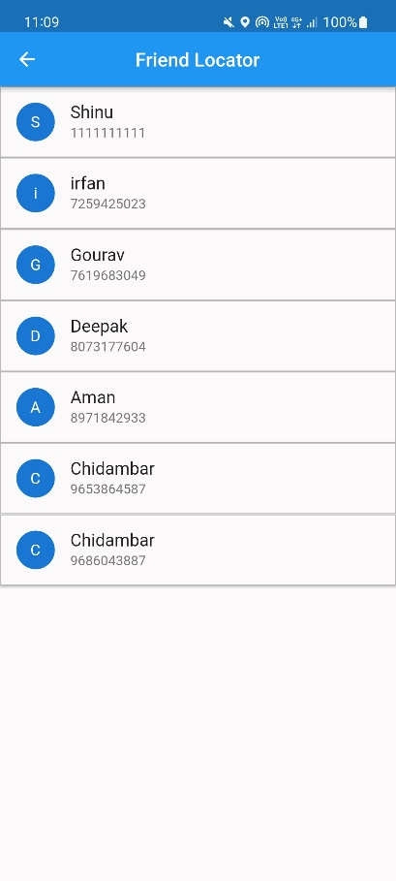 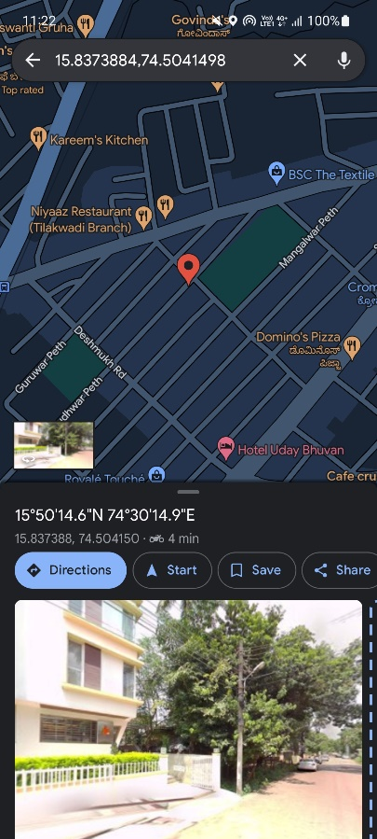

**WORKING CODE**

## activity_main.xml

*<?*xml version="1.0" encoding="utf-8"*?>*<AbsoluteLayout xmlns:android="http://schemas.android.com/apk/res/android"  
 xmlns:app="http://schemas.android.com/apk/res-auto"  
 xmlns:tools="http://schemas.android.com/tools"  
 android:layout_width="match_parent"  
 android:layout_height="match_parent"  
 android:orientation="vertical"  
 tools:context=".MainActivity">  
  
 <TextView  
 android:id="@+id/textView"  
 android:layout_width="match_parent"  
 android:layout_height="77dp"  
 android:layout_weight="1"  
 android:layout_x="0dp"  
 android:layout_y="22dp"  
 android:fontFamily="sans-serif"  
 android:text="Select a company to view stock details"  
 android:textAlignment="center"  
 android:textSize="30dp" />  
  
 <ImageButton  
 android:id="@+id/ItcBtn"  
 android:layout_width="120dp"  
 android:layout_height="153dp"  
 android:layout_weight="1"  
 android:layout_x="230dp"  
 android:layout_y="531dp"  
 android:background="@null"  
 app:srcCompat="@drawable/limited_itc" />  
  
 <ImageButton  
 android:id="@+id/GoogleBtn"  
 android:layout_width="120dp"  
 android:layout_height="153dp"  
 android:layout_weight="1"  
 android:layout_x="48dp"  
 android:layout_y="325dp"  
 android:background="@null"  
 app:srcCompat="@drawable/google" />  
  
 <ImageButton  
 android:id="@+id/AppleBtn"  
 android:layout_width="120dp"  
 android:layout_height="153dp"  
 android:layout_weight="1"  
 android:layout_x="48dp"  
 android:layout_y="531dp"  
 android:background="@null"  
 app:srcCompat="@drawable/apple" />  
  
 <ImageButton  
 android:id="@+id/TataBtn"  
 android:layout_width="120dp"  
 android:layout_height="153dp"  
 android:layout_weight="1"  
 android:layout_x="230dp"  
 android:layout_y="129dp"  
 android:background="@null"  
 app:srcCompat="@drawable/tata" />  
  
 <ImageButton  
 android:id="@+id/RelianceBtn"  
 android:layout_width="120dp"  
 android:layout_height="153dp"  
 android:layout_weight="1"  
 android:layout_x="230dp"  
 android:layout_y="325dp"  
 android:background="@null"  
 app:srcCompat="@drawable/reliance" />  
  
 <ImageButton  
 android:id="@+id/TeslaBtn"  
 android:layout_width="120dp"  
 android:layout_height="153dp"  
 android:layout_weight="1"  
 android:layout_x="48dp"  
 android:layout_y="131dp"  
 android:background="@null"  
 app:srcCompat="@drawable/tesla" />  
</AbsoluteLayout>

## activity_second.xml

*<?*xml version="1.0" encoding="utf-8"*?>*<AbsoluteLayout xmlns:android="http://schemas.android.com/apk/res/android"  
 xmlns:tools="http://schemas.android.com/tools"  
 android:layout_width="match_parent"  
 android:layout_height="match_parent">  
  
 <TextView  
 android:id="@+id/companyName"  
 android:layout_width="match_parent"  
 android:layout_height="wrap_content"  
 android:layout_gravity="center"  
 android:text="Company Name"  
 android:textSize="40sp"  
 android:textAlignment="center"  
 android:padding="12dp"  
 android:shadowColor="#80aaed"  
 android:shadowDx="12"  
 android:shadowDy="12"  
 android:shadowRadius="8"  
 android:textStyle="bold"/>  
  
  
 <TextView  
 android:id="@+id/symbol"  
 android:layout_width="102dp"  
 android:layout_height="wrap_content"  
 android:layout_gravity="center"  
 android:textAlignment="center"  
 android:layout_x="0dp"  
 android:layout_y="78dp"  
 android:padding="12dp"  
 android:shadowColor="#F12525"  
 android:shadowDx="12"  
 android:shadowDy="12"  
 android:shadowRadius="8"  
 android:text="Sym"  
 android:textSize="20sp"  
 android:textStyle="bold" />  
  
 <TextView  
 android:id="@+id/description"  
 android:layout_width="294dp"  
 android:layout_height="wrap_content"  
 android:layout_gravity="center"  
 android:layout_x="105dp"  
 android:layout_y="78dp"  
 android:padding="5dp"  
 android:text="This a a short description"  
 android:textSize="15sp" />  
  
 <TextView  
 android:id="@+id/textViewLow"  
 android:layout_width="151dp"  
 android:layout_height="53dp"  
 android:layout_x="140dp"  
 android:layout_y="554dp"  
 android:padding="10dp"  
 android:text="Loading.."  
 android:textSize="25dp"  
 tools:layout_editor_absoluteX="173dp"  
 tools:layout_editor_absoluteY="133dp" />  
  
 <TextView  
 android:id="@+id/stockDate"  
 android:layout_width="match_parent"  
 android:layout_height="53dp"  
 android:layout_x="2dp"  
 android:layout_y="338dp"  
 android:padding="10dp"  
 android:text="Stock details as of "  
 android:textAlignment="center"  
 android:textSize="25dp"  
 tools:layout_editor_absoluteX="173dp"  
 tools:layout_editor_absoluteY="133dp" />  
  
 <TextView  
 android:id="@+id/textView1"  
 android:layout_width="117dp"  
 android:layout_height="53dp"  
 android:layout_x="10dp"  
 android:layout_y="409dp"  
 android:padding="10dp"  
 android:text="Open:"  
 android:textSize="25dp"  
 tools:layout_editor_absoluteX="173dp"  
 tools:layout_editor_absoluteY="133dp" />  
  
 <TextView  
 android:id="@+id/textViewOpen"  
 android:layout_width="149dp"  
 android:layout_height="53dp"  
 android:layout_x="140dp"  
 android:layout_y="409dp"  
 android:padding="10dp"  
 android:text="Loading.."  
 android:textSize="25dp"  
 tools:layout_editor_absoluteX="173dp"  
 tools:layout_editor_absoluteY="133dp" />  
  
 <TextView  
 android:id="@+id/textView2"  
 android:layout_width="117dp"  
 android:layout_height="53dp"  
 android:layout_x="10dp"  
 android:layout_y="481dp"  
 android:padding="10dp"  
 android:text="High:"  
 android:textSize="25dp"  
 tools:layout_editor_absoluteX="173dp"  
 tools:layout_editor_absoluteY="133dp" />  
  
 <TextView  
 android:id="@+id/textViewHigh"  
 android:layout_width="151dp"  
 android:layout_height="53dp"  
 android:layout_x="140dp"  
 android:layout_y="481dp"  
 android:padding="10dp"  
 android:text="Loading.."  
 android:textSize="25dp"  
 tools:layout_editor_absoluteX="173dp"  
 tools:layout_editor_absoluteY="133dp" />  
  
 <TextView  
 android:id="@+id/textView3"  
 android:layout_width="117dp"  
 android:layout_height="53dp"  
 android:layout_x="10dp"  
 android:layout_y="554dp"  
 android:padding="10dp"  
 android:text="Low:"  
 android:textSize="25dp"  
 tools:layout_editor_absoluteX="173dp"  
 tools:layout_editor_absoluteY="133dp" />  
  
 <TextView  
 android:id="@+id/textViewClosed"  
 android:layout_width="151dp"  
 android:layout_height="53dp"  
 android:layout_x="140dp"  
 android:layout_y="624dp"  
 android:padding="10dp"  
 android:text="Loading.."  
 android:textSize="25dp"  
 tools:layout_editor_absoluteX="173dp"  
 tools:layout_editor_absoluteY="133dp" />  
  
 <TextView  
 android:id="@+id/textView4"  
 android:layout_width="117dp"  
 android:layout_height="53dp"  
 android:layout_x="10dp"  
 android:layout_y="624dp"  
 android:padding="10dp"  
 android:text="Close: "  
 android:textSize="25dp"  
 tools:layout_editor_absoluteX="173dp"  
 tools:layout_editor_absoluteY="133dp" />  
  
 <Button  
 android:id="@+id/idBtnPickDate"  
 android:layout_width="match_parent"  
 android:layout_height="wrap_content"  
 android:layout_centerInParent="true"  
 android:layout_margin="20dp"  
 android:layout_x="0dp"  
 android:layout_y="282dp"  
 android:text="Change Date"  
 android:background="@color/black"  
 android:textAllCaps="false" />  
  
</AbsoluteLayout>

## MainActivity.java

package com.example.courseactivity;  
  
import androidx.appcompat.app.AppCompatActivity;  
  
import android.app.AlertDialog;  
import android.app.ProgressDialog;  
import android.content.Intent;  
import android.os.Bundle;  
import android.view.View;  
import android.widget.ImageButton;  
  
import com.android.volley.Request;  
import com.android.volley.RequestQueue;  
import com.android.volley.Response;  
import com.android.volley.VolleyError;  
import com.android.volley.toolbox.StringRequest;  
import com.android.volley.toolbox.Volley;  
  
import org.json.JSONException;  
import org.json.JSONObject;  
  
import java.io.IOException;  
import java.io.InputStream;  
import java.util.HashMap;  
import java.util.Iterator;  
import java.util.Map;  
  
public class MainActivity extends AppCompatActivity {  
 *//Creating required Variables* ImageButton TeslaBtn;  
 ImageButton GoogleBtn;  
 ImageButton AppleBtn;  
 ImageButton TataBtn;  
 ImageButton RelianceBtn;  
 ImageButton ItcBtn;  
 String apikey = "";  
 ProgressDialog progress;  
 @Override  
 protected void onCreate(Bundle savedInstanceState) {  
 super.onCreate(savedInstanceState);  
 setContentView(R.layout.*activity_main*);  
 *//Finding views & initializing variables* TeslaBtn = (ImageButton) findViewById(R.id.*TeslaBtn*);  
 GoogleBtn = (ImageButton) findViewById(R.id.*GoogleBtn*);  
 AppleBtn = (ImageButton) findViewById(R.id.*AppleBtn*);  
 TataBtn = (ImageButton) findViewById(R.id.*TataBtn*);  
 RelianceBtn = (ImageButton) findViewById(R.id.*RelianceBtn*);  
 ItcBtn = (ImageButton) findViewById(R.id.*ItcBtn*);  
 progress = new ProgressDialog(MainActivity.this);  
  
 *//Extracting alpha vantage api-key from assets folder* try {  
 InputStream ip = getAssets().open("apikey.txt");  
 int size = ip.available();  
 byte[] buffer = new byte[size];  
 ip.read(buffer);  
 apikey = new String(buffer);  
 } catch (IOException e) {  
 e.printStackTrace();  
 }  
  
 TeslaBtn.setOnClickListener(new View.OnClickListener() {  
 @Override  
 public void onClick(View v) {  
 progress.setTitle("Loading"); *// setting title* progress.setMessage("Please wait ..."); *// creating message* progress.setProgressStyle(ProgressDialog.*STYLE_SPINNER*); *// style of indicator* progress.setIndeterminate(true);  
 progress.show();  
 String api ="https://www.alphavantage.co/query?function=TIME_SERIES_DAILY_ADJUSTED&symbol=TSLA&outputsize=compactl&apikey=" + apikey;  
 CompanyData c = new CompanyData("TESLA","TSLA","Tesla, Inc. is an American multinational automotive and clean energy company headquartered in Austin, Texas. Tesla designs and manufactures electric vehicles, battery energy storage from home to grid-scale, solar panels and solar roof tiles, and related products and services.","$");  
 getData(api,c);  
 }  
 });  
  
 GoogleBtn.setOnClickListener(new View.OnClickListener() {  
 @Override  
 public void onClick(View v) {  
 progress.setTitle("Loading"); *// setting title* progress.setMessage("Please wait ..."); *// creating message* progress.setProgressStyle(ProgressDialog.STYLE_SPINNER); *// style of indicator* progress.setIndeterminate(true);  
 progress.show();  
 String api ="https://www.alphavantage.co/query?function=TIME_SERIES_DAILY_ADJUSTED&symbol=GOOG&outputsize=compactl&apikey=" + apikey;  
 CompanyData c = new CompanyData("GOOGLE","GOOG","Google LLC is an American multinational technology company focusing on search engine technology, online advertising, cloud computing, computer software, quantum computing, e-commerce, artificial intelligence, and consumer electronics.","$");  
 getData(api,c);  
 }  
 });  
  
 AppleBtn.setOnClickListener(new View.OnClickListener() {  
 @Override  
 public void onClick(View v) {  
 progress.setTitle("Loading"); *// setting title* progress.setMessage("Please wait ..."); *// creating message* progress.setProgressStyle(ProgressDialog.STYLE_SPINNER); *// style of indicator* progress.setIndeterminate(true);  
 progress.show();  
 String api ="https://www.alphavantage.co/query?function=TIME_SERIES_DAILY_ADJUSTED&symbol=AAPL&outputsize=compactl&apikey=" + apikey;  
 CompanyData c = new CompanyData("APPLE","AAPL","Apple Inc. is an American multinational technology company headquartered in Cupertino, California, United States. Apple is the largest technology company by revenue (totaling US$365.8 billion in 2021) and, as of June 2022, is the world's biggest company by market capitalization, the fourth-largest personal computer vendor by unit sales and second-largest mobile phone manufacturer.","$");  
 getData(api,c);  
 }  
 });  
  
 TataBtn.setOnClickListener(new View.OnClickListener() {  
 @Override  
 public void onClick(View v) {  
 progress.setTitle("Loading"); *// setting title* progress.setMessage("Please wait ..."); *// creating message* progress.setProgressStyle(ProgressDialog.STYLE_SPINNER); *// style of indicator* progress.setIndeterminate(true);  
 progress.show();  
 String api ="https://www.alphavantage.co/query?function=TIME_SERIES_DAILY_ADJUSTED&symbol=TATAMOTORS.BSE&outputsize=compactl&apikey=" + apikey;  
 CompanyData c = new CompanyData("TATA","TATAMOTORS","The Tata Group is an Indian multinational conglomerate headquartered in Mumbai. Established in 1868, it is India's largest conglomerate, with products and services in over 150 countries, and operations in 100 countries across six continents.","₹");  
 getData(api,c);  
 }  
 });  
  
 RelianceBtn.setOnClickListener(new View.OnClickListener() {  
 @Override  
 public void onClick(View v) {  
 progress.setTitle("Loading"); *// setting title* progress.setMessage("Please wait ..."); *// creating message* progress.setProgressStyle(ProgressDialog.STYLE_SPINNER); *// style of indicator* progress.setIndeterminate(true);  
 progress.show();  
 String api ="https://www.alphavantage.co/query?function=TIME_SERIES_DAILY_ADJUSTED&symbol=RELIANCE.BSE&outputsize=compactl&apikey=" + apikey;  
 CompanyData c = new CompanyData("RELIANCE","RELIANCE","Reliance Industries Limited is an Indian multinational conglomerate company, headquartered in Mumbai. It has diverse businesses including energy, petrochemicals, natural gas, retail, telecommunications, mass media, and textiles.","₹");  
 getData(api,c);  
 }  
 });  
  
 ItcBtn.setOnClickListener(new View.OnClickListener() {  
 @Override  
 public void onClick(View v) {  
 progress.setTitle("Loading"); *// setting title* progress.setMessage("Please wait ..."); *// creating message* progress.setProgressStyle(ProgressDialog.STYLE_SPINNER); *// style of indicator* progress.setIndeterminate(true);  
 progress.show();  
 String api ="https://www.alphavantage.co/query?function=TIME_SERIES_DAILY_ADJUSTED&symbol=ITC.BSE&outputsize=compactl&apikey=" + apikey;  
 CompanyData c = new CompanyData("ITC Ltd","ITC","ITC Limited is an Indian conglomerate company headquartered in Kolkata. ITC has a diversified presence across industries such as FMCG, hotels, software, packaging, paperboards, specialty papers and agribusiness. The company has 13 businesses in 5 segments. It exports its products in 90 countries.","₹");  
 getData(api,c);  
 }  
 });  
 }  
  
 *//Using Volley library to make API request* private void getData(String api, CompanyData c){  
 RequestQueue queue = Volley.newRequestQueue(this);  
  
 StringRequest stringRequest = new StringRequest(Request.Method.GET, api,  
 new Response.Listener<String>() {  
 @Override  
 public void onResponse(String response) {  
 try {  
 JSONObject result = new JSONObject(response);  
 JSONObject obj = result.getJSONObject("Time Series (Daily)");  
 HashMap<String, Object> retMap = toMap(obj);  
  
 *//Passing the response to second activity* Intent i = new Intent(MainActivity.this,SecondActivity.class);  
 i.putExtra("hashMap", retMap);  
 i.putExtra("CompanyData",c);  
 startActivity(i);  
 progress.dismiss();  
  
 }catch (JSONException e) {  
 e.printStackTrace();  
 }  
 }  
 }, new Response.ErrorListener() {  
 @Override  
 public void onErrorResponse(VolleyError error) {  
 *//Log.e("api", "onErrorResponse: " + error.getLocalizedMessage());* progress.dismiss();  
 AlertDialog.Builder builder = new AlertDialog.Builder(MainActivity.this);  
 builder.setMessage("API request failed. Try again later!");  
 builder.setTitle("Alert !");  
 AlertDialog alertDialog = builder.create();  
 alertDialog.show();  
 }  
 });  
 queue.add(stringRequest);  
 }  
  
 *//Method to convert API response (JSON object) to required format (Hashmap)* public static HashMap<String, Object> toMap(JSONObject object) throws JSONException {  
 Map<String, Object> map = new HashMap<String, Object>();  
  
 Iterator<String> keysItr = object.keys();  
 while(keysItr.hasNext()) {  
 String key = keysItr.next();  
 Object value = object.get(key);  
 if(value instanceof JSONObject) {  
 value = toMap((JSONObject) value);  
 }  
 map.put(key, value);  
 }  
 return (HashMap<String, Object>) map;  
 }  
  
}

## SecondActivity.java

package com.example.courseactivity;  
  
import android.annotation.SuppressLint;  
import android.app.DatePickerDialog;  
import android.content.Intent;  
import android.graphics.text.LineBreaker;  
import android.os.Bundle;  
import android.view.View;  
import android.widget.Button;  
import android.widget.DatePicker;  
import android.widget.TextView;  
  
import androidx.appcompat.app.AppCompatActivity;  
  
import java.text.SimpleDateFormat;  
import java.util.Calendar;  
import java.util.Date;  
import java.util.HashMap;  
import java.util.Locale;  
  
public class SecondActivity extends AppCompatActivity {  
 *//Creating required Variables* TextView t1,t2,t3,t4;  
 TextView cName,cSymbol,cDesc;  
 TextView stockDate;  
 Button pickDateBtn;  
 *//For calculation of previous day date* private static final long *ONE_DAY_MILLI_SECONDS* = 24 * 60 * 60 * 1000;  
 @Override  
 protected void onCreate(Bundle savedInstanceState) {  
 super.onCreate(savedInstanceState);  
 setContentView(R.layout.*activity_second*);  
  
 *//Finding views & initializing variables* t1 = (TextView) findViewById(R.id.*textViewOpen*);  
 t2 = (TextView) findViewById(R.id.*textViewHigh*);  
 t3 = (TextView) findViewById(R.id.*textViewLow*);  
 t4 = (TextView) findViewById(R.id.*textViewClosed*);  
 cName = (TextView) findViewById(R.id.*companyName*);  
 cSymbol = (TextView) findViewById(R.id.*symbol*);  
 cDesc = (TextView) findViewById(R.id.*description*);  
 stockDate = (TextView) findViewById(R.id.*stockDate*);  
 pickDateBtn = findViewById(R.id.*idBtnPickDate*);  
  
 *//Defining date format* SimpleDateFormat df = new SimpleDateFormat("yyyy-MM-dd", Locale.*getDefault*());  
  
 *//Getting Previous Date - incase API isn't updated with current day details* Date currentDate = new Date();  
 long previousDayMilliSeconds =currentDate.getTime() - *ONE_DAY_MILLI_SECONDS*;  
 Date previousDate = new Date(previousDayMilliSeconds);  
 String prevDate = df.format(previousDate);  
 *//Getting Current Date* Date c = Calendar.*getInstance*().getTime();  
 String currentformattedDate = df.format(c);  
  
 Intent i = getIntent();  
 CompanyData CD = (CompanyData) i.getSerializableExtra("CompanyData");  
  
 *//Setting Company Details* cName.setText(CD.name);  
 cSymbol.setText(CD.symbol);  
 cDesc.setText(CD.desc);  
 cDesc.setJustificationMode(LineBreaker.*JUSTIFICATION_MODE_INTER_WORD*);  
  
 HashMap<String, HashMap<String,String>> hashMap = (HashMap<String, HashMap<String,String>>) i.getSerializableExtra("hashMap");  
 *//If API contains details as of current date* if (hashMap.containsKey(currentformattedDate)) {  
 stockDate.setText("Stock details as of "+ currentformattedDate);  
 t1.setText(CD.currency + hashMap.get(currentformattedDate).get("1. open"));  
 t2.setText(CD.currency + hashMap.get(currentformattedDate).get("2. high"));  
 t3.setText(CD.currency + hashMap.get(currentformattedDate).get("3. low"));  
 t4.setText(CD.currency + hashMap.get(currentformattedDate).get("4. close"));  
 }  
 *//If API isn't updated with current day details* else{  
 stockDate.setText("Stock details as of "+ prevDate);  
 t1.setText(CD.currency + hashMap.get(prevDate).get("1. open"));  
 t2.setText(CD.currency + hashMap.get(prevDate).get("2. high"));  
 t3.setText(CD.currency + hashMap.get(prevDate).get("3. low"));  
 t4.setText(CD.currency + hashMap.get(prevDate).get("4. close"));  
 }  
 *//Button to change dates & check stock details as of that day* pickDateBtn.setOnClickListener(new View.OnClickListener() {  
 @Override  
 public void onClick(View v) {  
 *// the instance of our calendar.* final Calendar c = Calendar.*getInstance*();  
 *// on below line we are getting  
 // our day, month and year.* int year = c.get(Calendar.*YEAR*);  
 int month = c.get(Calendar.*MONTH*);  
 int day = c.get(Calendar.*DAY_OF_MONTH*);  
  
 *// on below line we are creating a variable for date picker dialog.* DatePickerDialog datePickerDialog = new DatePickerDialog(  
 *// on below line we are passing context.* SecondActivity.this,  
 new DatePickerDialog.OnDateSetListener() {  
 @SuppressLint("SetTextI18n")  
 @Override  
 public void onDateSet(DatePicker view, int year,  
 int monthOfYear, int dayOfMonth) {  
 *// on below line we are setting date to our text view.* String selectedDate = year + "-" + (monthOfYear + 1) + "-" + dayOfMonth;  
 if (hashMap.containsKey(selectedDate)) {  
 stockDate.setText("Stock details as of "+ selectedDate);  
 t1.setText(CD.currency + hashMap.get(selectedDate).get("1. open"));  
 t2.setText(CD.currency + hashMap.get(selectedDate).get("2. high"));  
 t3.setText(CD.currency + hashMap.get(selectedDate).get("3. low"));  
 t4.setText(CD.currency + hashMap.get(selectedDate).get("4. close"));  
 }  
 }  
 },  
 *// on below line we are passing year,  
 // month and day for selected date in our date picker.* year, month, day);  
 *// at last we are calling show to  
 // display our date picker dialog.* datePickerDialog.show();  
 }  
 });  
 }  
}

## CompanyData.java

package com.example.courseactivity;  
  
import java.io.Serializable;  
  
public class CompanyData implements Serializable {  
 public String name;  
 public String desc;  
 public String symbol;  
 public String currency;  
 public CompanyData(String name,String symbol,String desc,String currency){  
 this.name = name;  
 this.symbol = symbol;  
 this.desc = desc;  
 this.currency = currency;  
 }  
}

**CONCLUSION**

In this project, a mobile application has been developed, FriendTracker, which:

1. SignUp/SignIn to use the application.
2. Update own location.
3. Allows adding friends to the list.
4. Display location of their friend.
5. Display maps.

**REFERENCES**

* https://spaceplace.nasa.gov/gps/en/
* https://www8.garmin.com/aboutGPS/
* https://en.wikipedia.org/wiki/Find_My_Friends
* https://www.lucidchart.com